|  |  |
| --- | --- |
|  | Student Name _______________________    **Eastern Goldfields College**  Mathematics U1 2018  Assignment – Calculator Free1 |
|  | **Time allowed: 15 minutes** Total Marks: 15 marks |

***Show all working where appropriate to obtain full marks.***

Question 1 (9 marks)

(a) At a certain time of day, the shadow of a 2 m tall post is 3.8 m long. Determine, at the same time of day, the length of the shadow of a tree that is 5 m tall. (3 marks)

(b) The two triangles shown below are similar. Determine the lengths  and . (3 marks)

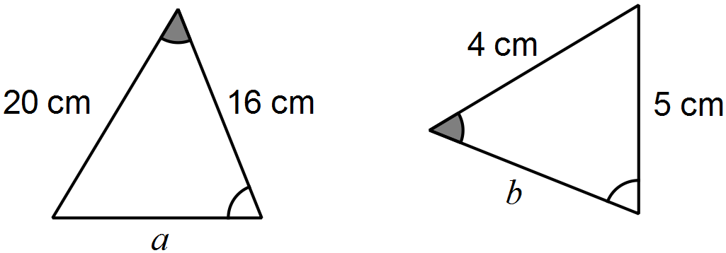

(c) An image, with one side that is 17 cm long, is enlarged so that the same side now measures 51 cm. If the original area of the image was 250 cm2, determine the area of the enlargement. (3 marks)

Question 2 (6 marks)

A system of one-way and two-way paths connects three locations A, B and C. There may be more than one path between any two locations. The table below shows the number of ways to travel between these locations using a single path.

|  |  |  |  |  |
| --- | --- | --- | --- | --- |
|  |  | To | | |
|  |  | A | B | C |
| From | A | 0 | 1 | 1 |
| B | 0 | 0 | 2 |
| C | 2 | 2 | 0 |

(a) Is the path between A and B one-way or two-way? Justify your answer. (1 mark)

(b) Complete the network diagram below to show the information in the table. (2 marks)

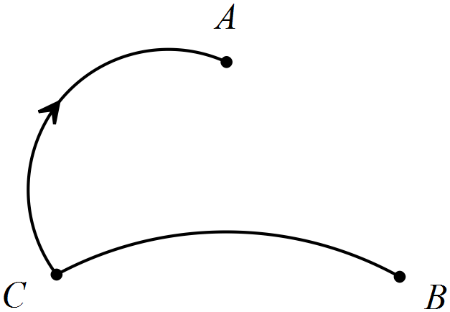

(c) Arrange the information from the table in a matrix  and determine the matrix . (3 marks)

|  |  |
| --- | --- |
|  | Student Name _______________________    **Eastern Goldfields College**  Mathematics U1 2018  Test 2 – Calculator Assumed1 |
|  | **Time allowed: 20 minutes** Total Marks: 18 marks |

**Calculator only permitted for this section, no notes.**

***Answer all of the following questions. Show all working to obtain full marks.***

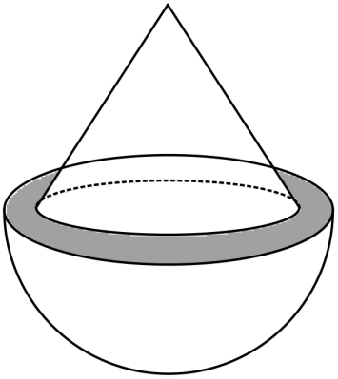

Question 1 (9 marks)

A solid cone of radius 12 cm and height 16 cm is placed   
symmetrically atop a solid hemisphere of radius 14 cm   
to form the composite solid shown right.

(a) Use Pythagoras' Theorem to calculate the   
slant height of the cone. (1 mark)

(b) Determine the area of the grey shaded ring, between the cone and the hemisphere, as shown in the diagram above. (2 marks)

(c) Determine the surface area of the composite solid. (3 marks)

(d) Calculate the volume of the composite solid. (3 marks)

**Question 2 (9 marks)**

The number of hours of labour required by each of workers A, B and C during the manufacture of three products P, Q and R is shown in the matrix M below.



(a) Explain the significance of the number in the second row and first column. (1 mark)

(b) Due to differing experience, workers A, B and C are paid $16, $20 and $22 per hour respectively. Express this information in the row matrix N that is consistent with the information in matrix M.

(1 mark)

(c) Determine the product of matrices M and N, in whatever order is possible, and explain what the resulting matrix S shows. (2 marks)

A standard production run consists of the manufacture of 3, 1 and 2 of products P, Q and R respectively.

(d) Write down a suitable matrix T so that the product ST will show the total labour cost for a standard production run and determine this total labour cost. (2 marks)

(e) During a standard production run, worker B is not available.

To maintain production, worker A takes on an extra four hours for product Q and worker C takes on an extra three hours for product R.

Determine, with justification, the effect this has on the total labour cost for a standard production run. (3 marks)

**End of Validation**